1 Walkthrough 34 Custom Control

<https://sapui5.hana.ondemand.com/#/topic/d12d2ee6a5454d799358d425f9e7c4db>

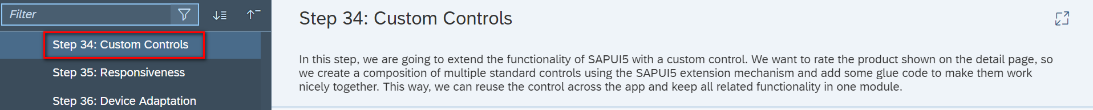

2 Core Changed Codes Compared to Last Version:

2.1 control/ProductRating.js 自定义UI控件

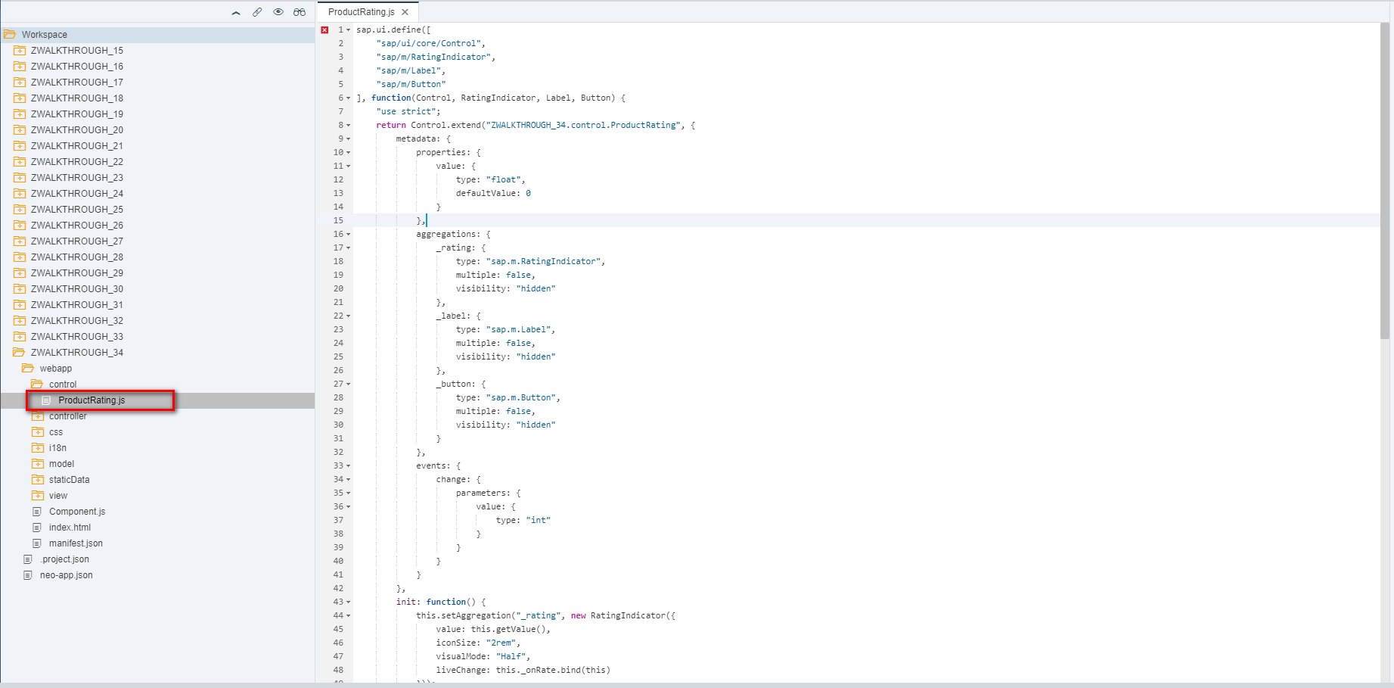

2.2 Detail.view.xml 添加自定义UI控件

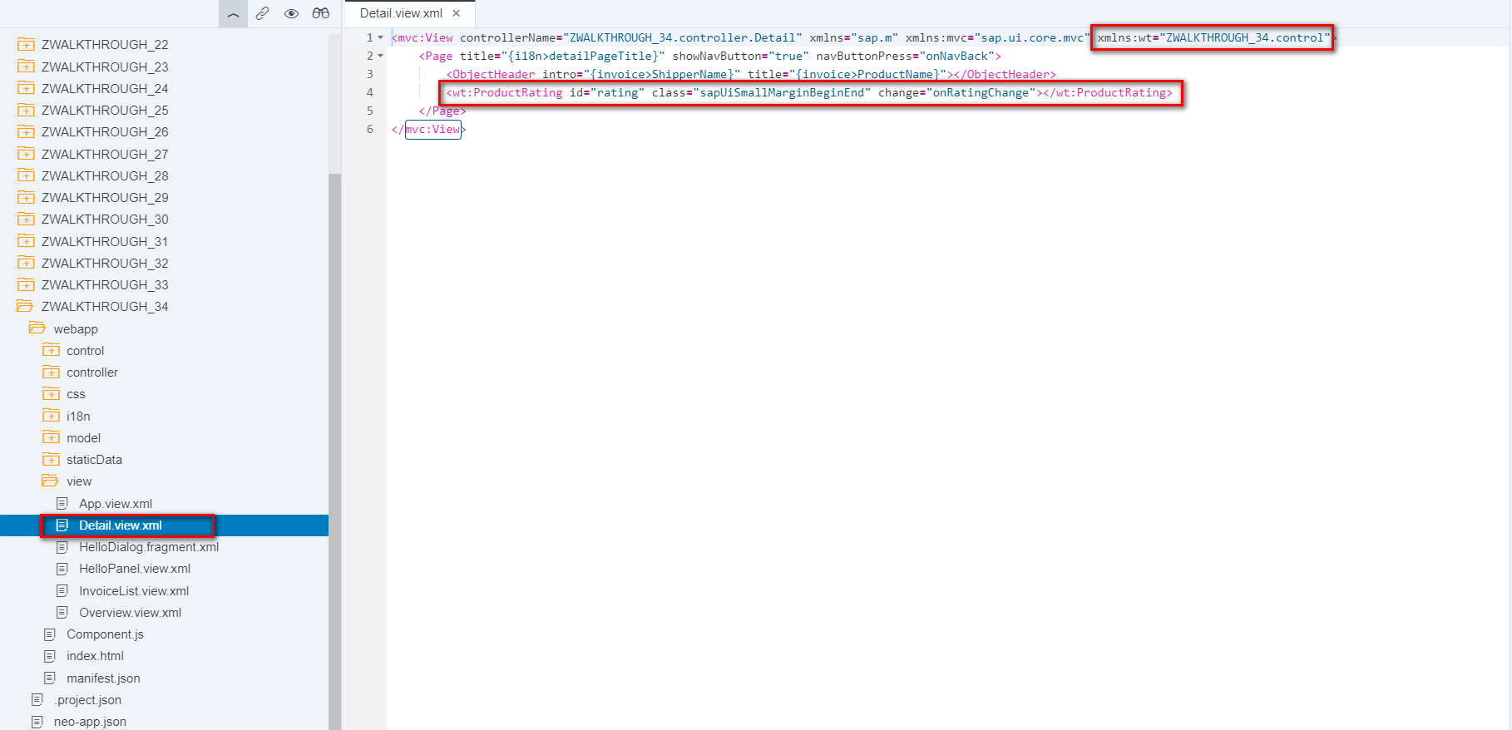

2.3 Detail.controller.js 响应自定义UI控件的行为,跳转初始化重置自定义UI控件

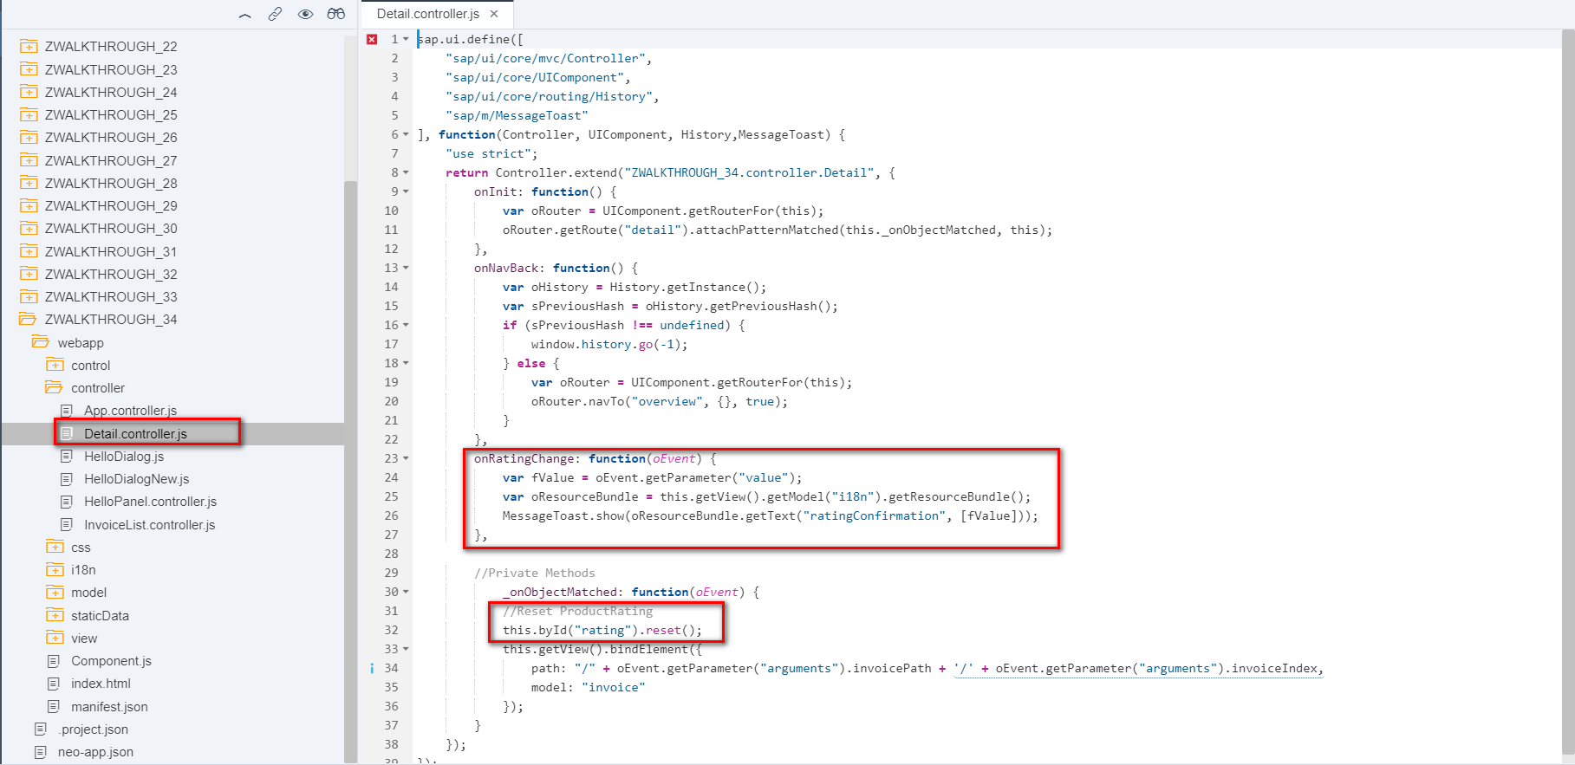

3 i18n 文本对象管理

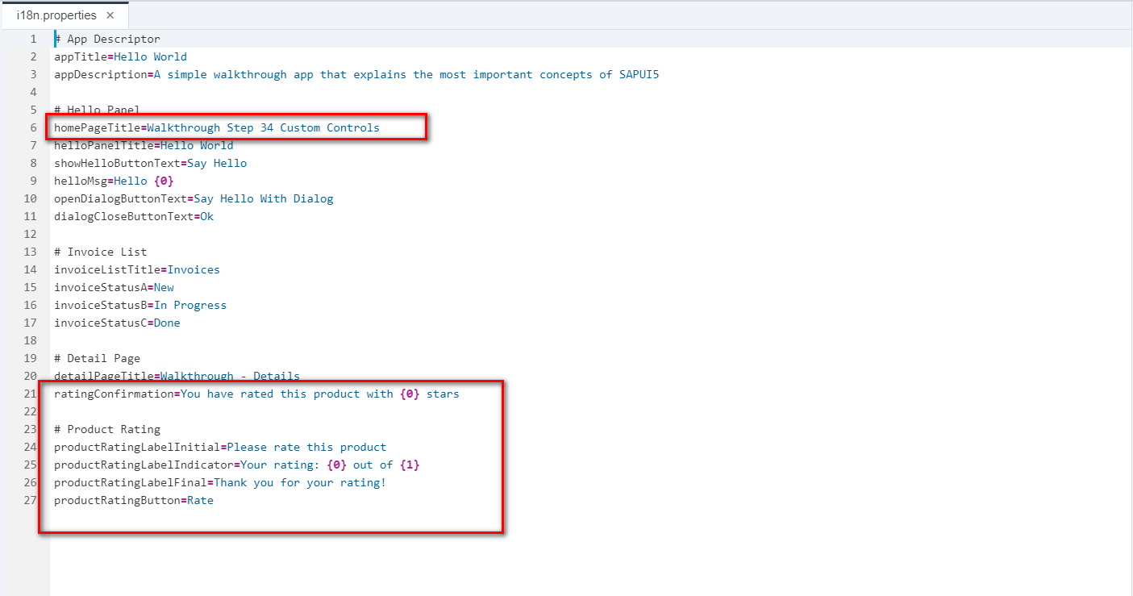

4 Result

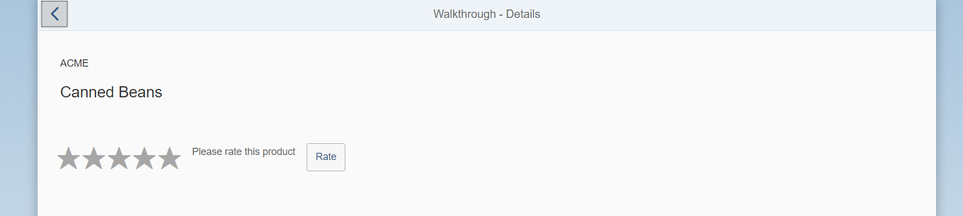

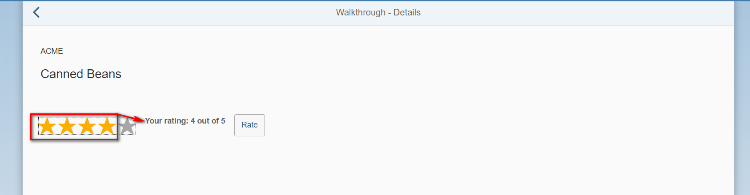

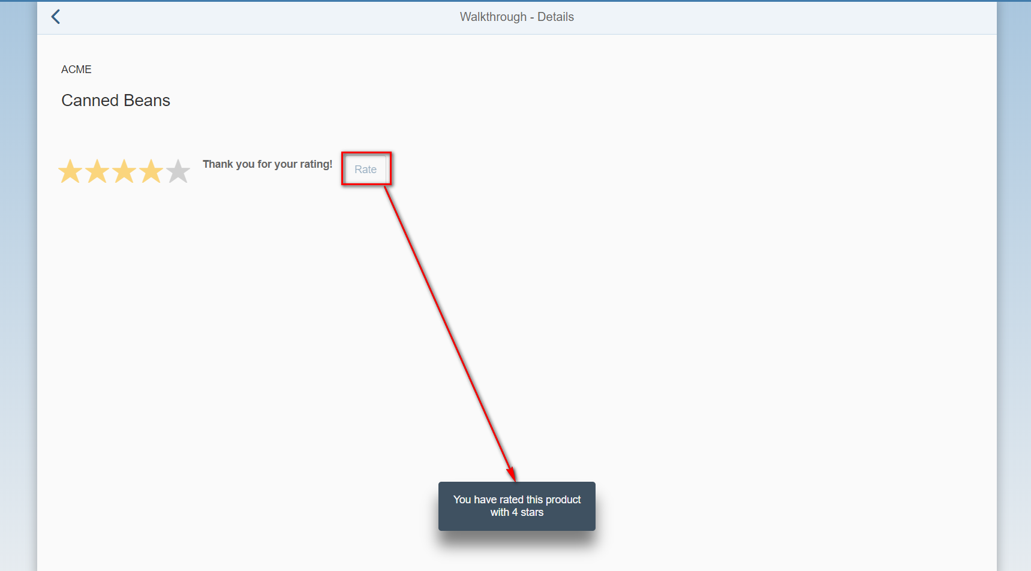

5 Git:

https://github.com/xiexiaop/SAPUI5-2-Round/tree/master/Projects/ZWALKTHROUGH_34

2019/02/08 XiaoMi Beijing Zac,Xie